Text Formatting Application

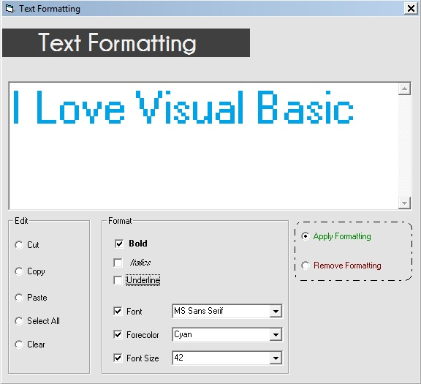

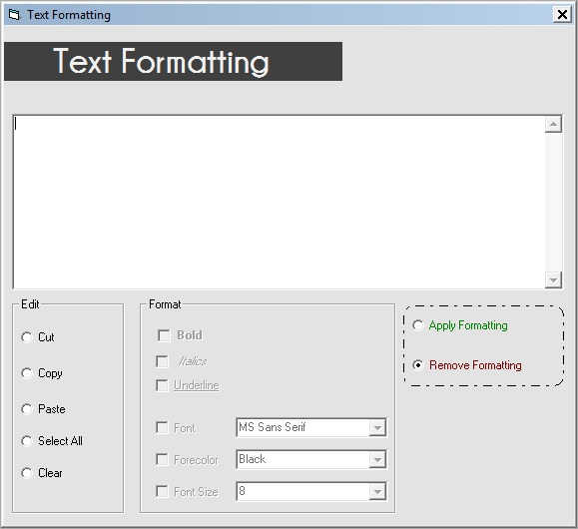

**Design Time Properties / Objects**

|  |  |
| --- | --- |
| **frmMain** | |
| Borderstyle | 1 – Fixed Single |
| Caption | Text Formatting |
|  | |
| **txtInput** | |
| Scrollbars | 2 - Vertical |
|  | |
| **optCut** | |
| Caption | Cut |
|  | |
| **optCopy** | |
| Caption | Copy |
|  | |
| **optPaste** | |
| Caption | Paste |
|  | |
| **chkBold** | |
| Caption | Bold |
|  | |
| **chkItalic** | |
| Caption | Italic |
|  | |
| **chkUnderline** | |
| Caption | Underline |
|  | |
| **chkColor** | |
| Caption | Forecolor |
|  | |
| **chkSize** | |
| Caption | Size |
|  | |
| **cmbColor** | |
|  | |
| **cmbSize** | |

|  |  |
| --- | --- |
| **optApply** | |
| Caption | Apply Formatting |
|  | |
| **OptRemove** | |
| Caption | Remove Formatting |
|  | |
| **optSelect** | |
| Caption | Select All |
|  | |
| **optClear** | |
| Caption | Clear |
|  | |
| **fmeEdit** | |
| Caption | Edit |
|  | |
| **fmeFormat** | |
| Caption | Format |
|  | |

**Code**

**Private Sub EnableControls()**

chkBold.Enabled = True

chkItalic.Enabled = True

chkUnderline.Enabled = True

chkFont.Enabled = True

chkColor.Enabled = True

chkSize.Enabled = True

Call chkColor_Click

Call chkSize_Click

Call chkFont_Click

Call Format

**End Sub**

**Private Sub DisableControls()**

chkBold.Enabled = False

chkItalic.Enabled = False

chkUnderline.Enabled = False

chkFont.Enabled = False

chkColor.Enabled = False

chkSize.Enabled = False

cmbFont.Enabled = False

cmbColor.Enabled = False

cmbSize.Enabled = False

txtInput.Font = "MS Sans Serif"

txtInput.FontBold = False

txtInput.FontItalic = False

txtInput.FontUnderline = False

txtInput.FontSize = 8

txtInput.ForeColor = vbBlack

**End Sub**

**Private Sub SetColor()**

Select Case cmbColor.ListIndex

Case 0: txtInput.ForeColor = vbBlack

Case 1: txtInput.ForeColor = vbRed

Case 2: txtInput.ForeColor = vbGreen

Case 3: txtInput.ForeColor = vbBlue

Case 4: txtInput.ForeColor = vbYellow

Case 5: txtInput.ForeColor = RGB(255, 74, 133)

Case 6: txtInput.ForeColor = RGB(163, 73, 164)

Case 7: txtInput.ForeColor = RGB(0, 162, 232)

End Select

**End Sub**

**Private Sub Format()**

If chkBold.Value = 1 Then txtInput.FontBold = True _

Else txtInput.FontBold = False

If chkItalic.Value = 1 Then txtInput.FontItalic = True _

Else txtInput.FontItalic = False

If chkUnderline.Value = 1 Then txtInput.FontUnderline = True _

Else txtInput.FontUnderline = False

If chkFont.Value = 1 Then txtInput.Font = cmbFont.Text _

Else txtInput.Font = "MS Sans Serif"

If chkColor.Value = 1 Then SetColor _

Else txtInput.ForeColor = vbBlack

If chkSize.Value = 1 Then txtInput.FontSize = Val(cmbSize.Text) _

Else txtInput.FontSize = 8

**End Sub**

**Private Sub optApply_Click()**

Call EnableControls

**End Sub**

**Private Sub chkColor_Click()**

If chkColor.Value = 1 Then cmbColor.Enabled = True Else cmbColor.Enabled = False

Call Format

**End Sub**

**Private Sub chkFont_Click()**

If chkFont.Value = 1 Then cmbFont.Enabled = True Else cmbFont.Enabled = False

Call Format

**End Sub**

**Private Sub chkItalic_Click()**

Call Format

**End Sub**

**Private Sub optRemove_Click()**

Call DisableControls

**End Sub**

**Private Sub chkSize_Click()**

If chkSize.Value = 1 Then cmbSize.Enabled = True _

Else cmbSize.Enabled = False

Call Format

**End Sub**

**Private Sub chkUnderline_Click()**

Call Format

**End Sub**

**Private Sub cmbColor_click()**

Call Format

**End Sub**

**Private Sub chkBold_Click()**

Call Format

**End Sub**

**Private Sub cmbFont_click()**

Call Format

**End Sub**

**Private Sub cmbSize_click()**

Call Format

**End Sub**

**Private Sub Form_Load()**

cmbFont.AddItem ("MS Sans Serif")

cmbFont.AddItem ("Times New Roman")

cmbFont.AddItem ("Arial")

cmbFont.AddItem ("Comic Sans MS")

cmbFont.AddItem ("Courier New")

cmbFont.AddItem ("Georgia")

cmbFont.ListIndex = 0

cmbColor.AddItem ("Black")

cmbColor.AddItem ("Red")

cmbColor.AddItem ("Green")

cmbColor.AddItem ("Blue")

cmbColor.AddItem ("Yellow")

cmbColor.AddItem ("Pink")

cmbColor.AddItem ("Purple")

cmbColor.AddItem ("Cyan")

cmbColor.ListIndex = 0

cmbSize.AddItem ("8")

cmbSize.AddItem ("12")

cmbSize.AddItem ("20")

cmbSize.AddItem ("28")

cmbSize.AddItem ("32")

cmbSize.AddItem ("38")

cmbSize.AddItem ("42")

cmbSize.AddItem ("48")

cmbSize.ListIndex = 0

Call optRemove_Click

optRemove.Value = True

**End Sub**

**Private Sub optClear_Click()**

txtInput.Text = ""

optClear.Value = False

**End Sub**

**Private Sub optSelect_Click()**

txtInput.SetFocus

txtInput.SelStart = 0

txtInput.SelLength = Len(txtInput.Text)

optSelect.Value = False

**End Sub**

**Private Sub optCopy_Click()**

Clipboard.SetText (txtInput.SelText)

optCopy.Value = False

**End Sub**

**Private Sub optCut_Click()**

Clipboard.SetText (txtInput.SelText)

txtInput.SelText = ""

optCut.Value = False

**End Sub**

**Private Sub optPaste_Click()**

txtInput.SelText = Clipboard.GetText

optPaste.Value = False

**End Sub**

Ordering Application

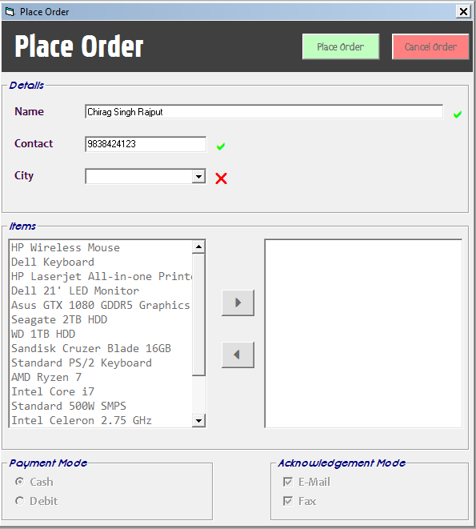

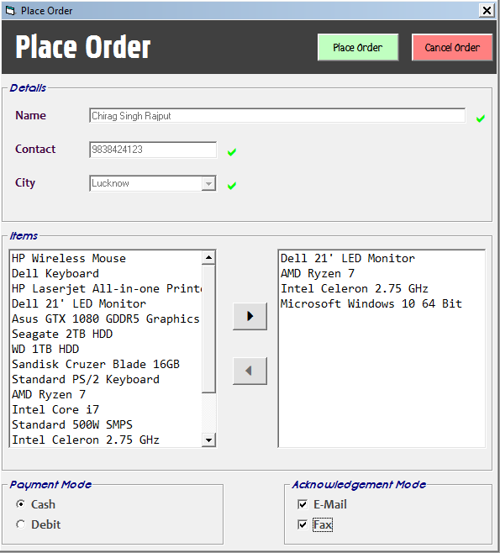

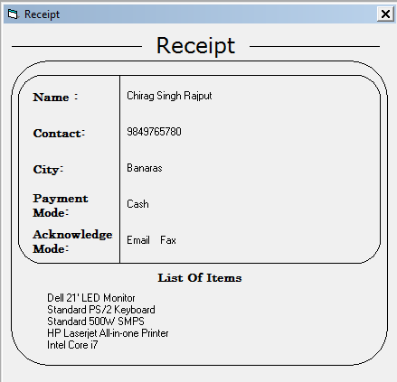

**Design Time Properties**

|  |  |
| --- | --- |
| **frmMain** | |
| Caption | Place Order |
| BorderStyle | 1 – Fixed Single |
|  | |
| **lblTitle** | |
| Caption | Place Order |
|  | |
| **fmeDetails** | |
| Name | fmeDetails |
|  | |
| **fmeProduct** | |
| Caption | Items |
|  | |
| **fmePayment** | |
| Caption | Payment Mode |
|  | |
| **fmeAcknowledge** | |
| Caption | Acknowledge Mode |
|  | |
| **lblName** | |
| Caption | Name |
|  | |
| **lblContact** | |
| Caption | Contact |
|  | |
| **lblCity** | |
| Caption | City |
|  | |
| **txtName** | |
|  | |
| **txtContact** | |
| Maxlength | 10 |
|  | |
| **cmbCity** | |
|  | |
| **lstProduct** | |
| Font | Consolas |
| Enabled | False |

|  |  |
| --- | --- |
| **cmdAdd** | |
| Font | Webdings |
| Caption | 4 |
| Enabled | False |
|  | |
| **cmdRemove** | |
| Font | Webdings |
| Caption | 3 |
| Enabled | False |
|  | |
| **OptCash** | |
| Caption | Cash |
| Enabled | False |
|  | |
| **OptCard** | |
| Caption | Debit |
| Enabled | False |
|  | |
| **chkEmail** | |
| Caption | Email |
| Enabled | False |
|  | |
| **chkFax** | |
| Caption | Fax |
| Enabled | False |
|  | |
| **cmdPlace** | |
| Caption | Place Order |
| BackColor | &H00C0FFC0& |
| Enabled | False |
|  | |
| **cmdReset** | |
| Caption | Cancel Order |
| BackColor | &H008080FF& |
| Enabled | False |
|  | |
| **lstOrder** | |
| Font | Consolas |
| Enabled | False |

|  |  |
| --- | --- |
| **lblCityE** |  |
| Caption | r |
| Font | Webdings |
| Forecolor | &H000000FF& |

|  |  |
| --- | --- |
| **lblNameE** | |
| Caption | r |
| Font | Webdings |
| Forecolor | &H000000FF& |
|  | |
| **lblContactE** |  |
| Caption | r |
| Font | Webdings |
| Forecolor | &H000000FF& |

**Code**

**Private Sub Validate()**

If txtName.Text <> "" And Len(txtNumber.Text) = 10 And cmbCity.Text <> "" Then

lstOrder.Enabled = True

lstProduct.Enabled = True

cmdAdd.Enabled = False

cmdRemove.Enabled = False

optCash.Enabled = True

optCard.Enabled = True

chkEmail.Enabled = True

chkFax.Enabled = True

cmdPlace.Enabled = True

cmdReset.Enabled = True

lblCityE.Caption = "a": lblCityE.ForeColor = vbGreen

lblNumberE.Caption = "a": lblNumberE.ForeColor = vbGreen

lblNameE.Caption = "a": lblNameE.ForeColor = vbGreen

txtName.Enabled = False

txtNumber.Enabled = False

cmbCity.Enabled = False

lstProduct.ListIndex = 0

Else

If txtName.Text = "" Then

lblNameE.Caption = "r": lblNameE.ForeColor = vbRed

Else

lblNameE.Caption = "a": lblNameE.ForeColor = vbGreen

End If

If Len(txtNumber.Text) < 10 Then

lblNumberE.Caption = "r": lblNumberE.ForeColor = vbRed

Else

lblNumberE.Caption = "a": lblNumberE.ForeColor = vbGreen

End If

If cmbCity.Text = "" Then

lblCityE.Caption = "r": lblCityE.ForeColor = vbRed

Else

lblCityE.Caption = "a": lblCityE.ForeColor = vbGreen

End If

End If

**End Sub**

**Private Sub cmdAdd_Click()**

lstOrder.AddItem (lstProduct.List(lstProduct.ListIndex))

**End Sub**

**Private Sub cmdPlace_Click()**

If lstOrder.ListCount = 0 Then _

userInput = MsgBox("No Items Selected!", vbOKOnly + vbCritical, "Error!"): Exit Sub

'Receipt Generate

frmReceipt.lblNameDisp.Caption = txtName.Text

frmReceipt.lblContactDisp.Caption = txtNumber.Text

frmReceipt.lblCityDisp.Caption = cmbCity.Text

If chkEmail.Value = 1 Then _

frmReceipt.lblAcknowledgementDisp.Caption = "Email "

If chkFax.Value = 1 Then _

frmReceipt.lblAcknowledgementDisp.Caption = frmReceipt.lblAcknowledgementDisp.Caption + "Fax"

If optCash.Value = True Then _

frmReceipt.lblPaymentDisp.Caption = "Cash" Else frmReceipt.lblPaymentDisp.Caption = "Card"

For i = 0 To lstOrder.ListCount - 1

frmReceipt.lblItemList.Caption = frmReceipt.lblItemList.Caption + lstOrder.List(i) + vbCr

Next i

frmReceipt.Height = frmReceipt.lblItemList.Height + 5175

frmReceipt.Shape1.Height = 3900 + frmReceipt.lblItemList.Height

frmMain.Hide

frmReceipt.Show

**End Sub**

**Private Sub cmdRemove_Click()**

lstOrder.RemoveItem (lstOrder.ListIndex)

cmdRemove.Enabled = False

**End Sub**

**Private Sub cmdReset_Click()**

txtName.Text = ""

txtNumber.Text = ""

cmbCity.Text = ""

lstOrder.Clear

txtName.Enabled = True

txtNumber.Enabled = True

cmbCity.Enabled = True

lstProduct.Enabled = False

lstOrder.Enabled = False

cmdAdd.Enabled = False

cmdRemove.Enabled = False

cmdPlace.Enabled = False

cmdReset.Enabled = False

chkEmail.Enabled = False

chkFax.Enabled = False

optCard.Enabled = False

optCash.Enabled = False

optCash.Value = True

chkEmail.Value = 1

chkFax.Value = 1

Validate

**End Sub**

**Private Sub Form_Load()**

cmbCity.Clear

cmbCity.AddItem ("Lucknow")

cmbCity.AddItem ("Gurgoan")

cmbCity.AddItem ("Kanpur")

cmbCity.AddItem ("Banaras")

cmbCity.AddItem ("Sitapur")

cmbCity.AddItem ("Allahabad")

cmbCity.AddItem ("Noida")

cmbCity.AddItem ("Gorakhpur")

cmbCity.AddItem ("Meerut")

cmbCity.AddItem ("Aligrah")

lstProduct.AddItem ("HP Wireless Mouse")

lstProduct.AddItem ("Dell Keyboard")

lstProduct.AddItem ("HP Laserjet All-in-one Printer")

lstProduct.AddItem ("Dell 21' LED Monitor")

lstProduct.AddItem ("Asus GTX 1080 GDDR5 Graphics Card")

lstProduct.AddItem ("Seagate 2TB HDD")

lstProduct.AddItem ("WD 1TB HDD")

lstProduct.AddItem ("Sandisk Cruzer Blade 16GB")

lstProduct.AddItem ("Standard PS/2 Keyboard")

lstProduct.AddItem ("AMD Ryzen 7")

lstProduct.AddItem ("Intel Core i7")

lstProduct.AddItem ("Standard 500W SMPS")

lstProduct.AddItem ("Intel Celeron 2.75 GHz")

lstProduct.AddItem ("HP 15' Monitor")

lstProduct.AddItem ("Luminous UPS")

lstProduct.AddItem ("Microsoft Windows 10 64 Bit")

lstProduct.AddItem ("Quick Heal Anti Virus Security")

optCash.Value = True

chkEmail.Value = 1

chkFax.Value = 1

**End Sub**

**Private Sub lstOrder_gotFocus()**

cmdAdd.Enabled = False

cmdRemove.Enabled = True

**End Sub**

**Private Sub lstProduct_GotFocus()**

cmdRemove.Enabled = False

cmdAdd.Enabled = True

**End Sub**

**Private Sub txtNumber_KeyPress(KeyAscii As Integer)**

If (KeyAscii >= vbKey0 And KeyAscii <= vbKey9) Or KeyAscii = vbKeyBack Then

Exit Sub

Else

KeyAscii = 0

End If

**End Sub**

**Private Sub txtName_change()**

Validate

**End Sub**

**Private Sub txtNumber_change()**

Validate

**End Sub**

**Private Sub cmbCity_Click()**

Validate

**End Sub**

Marksheeet Application

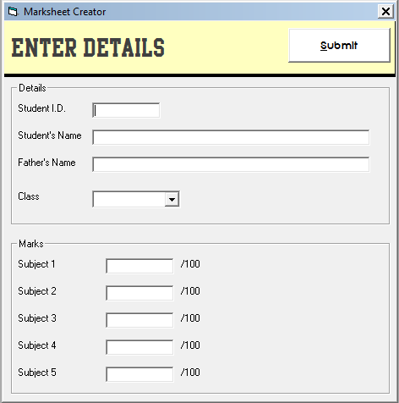

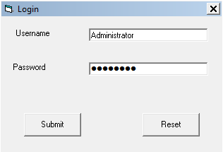

Design Time Properties/Objects

|  |  |
| --- | --- |
| **frmLogin** | (Login Form) |
| BorderStyle | 1 –Fixed Single |
| Caption | Login |
|  | |
| **lblUsername** | |
| Caption | Username |
|  |  |
| **lblPassword** | |
| Caption | Password |
|  | |
| **txtUsername** | |
|  | |
| **txtPassword** | |
| Font | Webdings |
| PasswordChar | L |
|  | |
| **cmdSubmit** | |
| Caption | &Submit |
|  | |
| **cmdReset** | |
| Caption | Reset |
|  | |
| **frmMain** | (Input Form) |
| Caption | Marksheet Creator |
| BorderStyle | 1- Fixed Single |
|  |  |
| **lblTitle** | |
| Caption | Enter Details |
|  | |
| **fmeDetails** | |
| Caption | Details |
|  | |
| **lblNameShow** | |
| Caption | Name |
|  |  |
| **lblStuName** | |
| Caption | Student’s Name |
|  |  |
| **lblFatherName** | |
| Caption | Father’s Name |
|  | |
| **lblClass** | |
| Caption | Class |
|  |  |
| **txtId** | |
| Maxlength | 10 |
|  | |
| **txtName**  **txtFather**  **cmbClass** |  |
|  | |
| **lblSub1** to **lblSub5** |  |
| Caption | Subject 1 to Subject 5 |
|  | |
| **txtSub1 to txtSub5** | (Input Box For Marks) |
|  | |
| **lblMax1 to lblMax5** | |
| Caption | /100 |

|  |  |
| --- | --- |
| **lblDateD** | |
| Caption | Date |
|  | |
| **lblTimeD** |  |
| Caption | Time |
|  | |
| **fmeDetails** | |
| Caption | Details |
|  | |
| **lblId** | |
| Caption | Student’s ID |
|  | |
| **lblStuName** | |
| Caption | Student’s Name |
|  | |
| **lblFathername** | |
| Caption | Father’s Name |
|  | |
| **lblClass** |  |
| Caption | Class |
|  | |
| **lblIDShow**  **lblNameShow**  **lblFatherShow**  **lblClassShow**  **lblSub1Show**  **lblSub2Show**  **lblSub3Show**  **lblSub4Show**  **lblSub5Show**  **lblDate**  **lblTime** | Lables for displaying details on the marksheet. |
|  | |
| **lblMax1** to **lblMax5** |  |
| Caption | /100 |
|  | |
| **lblSub1** to **lblSub5** | |
| Caption | Subject 1 to Subject 5 |
|  | |
| **lblTotalShow** | |
| Caption | Total |
|  | |
| **lblPercentShow** | |
| Caption | Percent |
|  | |
| **lblTotal**  **lblPercent** | Lables for Displaying Total Marks and Percentage |
|  | |
| **cmdExit** | |
| Caption | &Exit |

|  |  |
| --- | --- |
| **frmMarksheet** |  |
| Caption | Marksheet |
| BorderStyle | 1 – Fixed Single |
|  | |
| **frmMarksheet** |  |
| Caption | Marksheet |
| BorderStyle | 1 – Fixed Single |
|  | |
| **frmMarksheet** |  |
| Caption | Marksheet |
| BorderStyle | 1 – Fixed Single |

Code

frmLogin :

Private Sub cmdReset_Click()

Call reset

End Sub

Private Sub cmdSubmit_Click()

If LCase(txtUsername.Text) = "administrator" And LCase(txtPassword.Text) = "password" Then _

Load frmMain Else Call MsgBox("Invalid Input!", vbOKOnly + vbCritical, "Error")

End Sub

Public Sub reset()

txtUsername.Text = ""

txtPassword.Text = ""

End Sub

frmMain :

Private Sub cmdSubmit_Click()

getValues

frmMain.Hide

Load frmMarkSheet

End Sub

Private Sub getValues()

stuID = txtID.Text

stuName = txtName.Text

stuFather = txtFather.Text

Class = cmbClass.Text

sub1 = Val(txtSub1.Text)

sub2 = Val(txtSub2.Text)

sub3 = Val(txtSub3.Text)

sub4 = Val(txtSub4.Text)

sub5 = Val(txtSub5.Text)

End Sub

Private Sub Form_Load()

Unload frmLogin

Load frmMain

frmMain.Show

cmbClass.Clear

cmbClass.AddItem ("B.C.A")

cmbClass.AddItem ("B.Sc")

cmbClass.AddItem ("B.Com.")

cmbClass.AddItem ("B.A.")

End Sub

Private Sub txtID_KeyPress(KeyAscii As Integer)

If ((KeyAscii >= vbKey0 And KeyAscii <= vbKey9) Or KeyAscii = vbKeyBack) Then

Exit Sub

Else

KeyAscii = 0

Beep

End If

End Sub

Private Sub txtSub1_Change()

If (Val(txtSub1.Text) < 0 Or Val(txtSub1.Text) > 100) Then

txtSub1.Text = ""

End If

End Sub

Private Sub txtSub2_Change()

If (Val(txtSub2.Text) < 0 Or Val(txtSub2.Text) > 100) Then

txtSub2.Text = ""

End If

End Sub

Private Sub txtSub3_Change()

If (Val(txtSub3.Text) < 0 Or Val(txtSub3.Text) > 100) Then

txtSub3.Text = ""

End If

End Sub

Private Sub txtSub4_Change()

If (Val(txtSub4.Text) < 0 Or Val(txtSub4.Text) > 100) Then

txtSub4.Text = ""

End If

End Sub

Private Sub txtSub5_Change()

If (Val(txtSub5.Text) < 0 Or Val(txtSub5.Text) > 100) Then

txtSub5.Text = ""

End If

End Sub

Private Sub txtSub2_KeyPress(KeyAscii As Integer)

If ((KeyAscii >= vbKey0 And KeyAscii <= vbKey9) Or KeyAscii = vbKeyBack) Then

Exit Sub

Else

KeyAscii = 0

End If

End Sub

Private Sub txtSub3_KeyPress(KeyAscii As Integer)

If ((KeyAscii >= vbKey0 And KeyAscii <= vbKey9) Or KeyAscii = vbKeyBack) Then

Exit Sub

Else

KeyAscii = 0

End If

End Sub

Private Sub txtSub4_KeyPress(KeyAscii As Integer)

If ((KeyAscii >= vbKey0 And KeyAscii <= vbKey9) Or KeyAscii = vbKeyBack) Then

Exit Sub

Else

KeyAscii = 0

End If

End Sub

Private Sub txtSub5_KeyPress(KeyAscii As Integer)

If ((KeyAscii >= vbKey0 And KeyAscii <= vbKey9) Or KeyAscii = vbKeyBack) Then

Exit Sub

Else

KeyAscii = 0

End If

End Sub

frmMarkSheet :

Private Sub cmdExit_Click()

End

End Sub

Private Sub fmeDetails_DragDrop(Source As Control, X As Single, Y As Single)

End Sub

Private Sub Form_Load()

lblIDShow.Caption = frmMain.txtID.Text

lblNameshow.Caption = frmMain.txtName.Text

lblFatherShow.Caption = frmMain.txtFather.Text

lblClassShow.Caption = frmMain.cmbClass.Text

lblSub1Show.Caption = frmMain.txtSub1.Text

lblSub2Show.Caption = frmMain.txtSub2.Text

lblSub3Show.Caption = frmMain.txtSub3.Text

lblSub4Show.Caption = frmMain.txtSub4.Text

lblSub5Show.Caption = frmMain.txtSub5.Text

lblTotal.Caption = Val(frmMain.txtSub1.Text) + Val(frmMain.txtSub2.Text) + Val(frmMain.txtSub3.Text) + Val(frmMain.txtSub4.Text) + Val(frmMain.txtSub5.Text)

lblPercent.Caption = Format(Val(lblTotal.Caption) / 500, "##0.00%")

lblTime.Caption = Format(Now, "hh:mm:ss")

lblDate.Caption = Format(Now, "dd/mm/yyyy")

frmMarkSheet.Show

End Sub

Expression Calculator

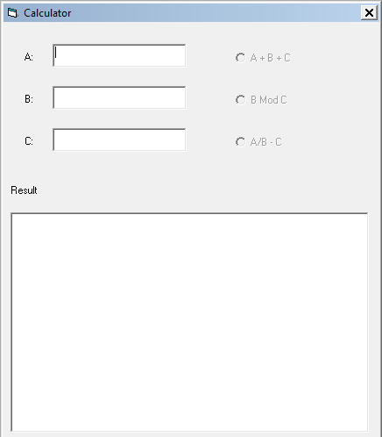

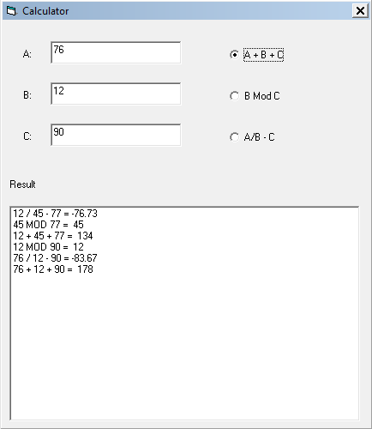

Design Time Properties/Objects

|  |  |
| --- | --- |
| **lblA** | |
| Caption | A: |
|  | |
| **lblB** | |
| Caption | B: |
|  | |
| **lblC** |  |
| Caption | C: |
|  | |
| **lblResult** | |
| Caption | Result |
|  | |
| **lstOperationList** | List to hold Expressions |

|  |  |
| --- | --- |
| **frmMain** | |
| Caption | Calculator |
| Border | 1 – Fixed Single |
|  | |
| **txtA**  **txtB**  **txtC** | Inputs |
|  | |
| **optOperation1** |  |
| Caption | A + B + C |
|  | |
| **optOperation2** |  |
| Caption | B Mod C |
|  | |
| **optOperation3** |  |
| Caption | A/B - C |

Code

Private Sub Form_Load()

Call Validate

End Sub

Private Sub optOperation1_Click()

lstOperationList.AddItem (txtA.Text + " + " + txtB.Text + " + " + txtC.Text + " = " + Str(Val(txtA.Text) + Val(txtB.Text) + Val(txtC.Text)))

End Sub

Private Sub optOperation2_Click()

lstOperationList.AddItem (txtB.Text + " MOD " + txtC.Text + " = " + Str(Val(txtB.Text) Mod Val(txtC.Text)))

End Sub

Private Sub optOperation3_Click()

lstOperationList.AddItem (txtA.Text + " / " + txtB.Text + " - " + txtC.Text + " = " + Format(Val(txtA.Text) / Val(txtB.Text) - Val(txtC.Text), "##0.00"))

End Sub

Private Sub txtA_KeyPress(KeyAscii As Integer)

If (KeyAscii >= vbKey0 And KeyAscii <= vbKey9) Or KeyAscii = vbKeyBack Then

Exit Sub

Else

KeyAscii = 0

End If

End Sub

Private Sub txtB_KeyPress(KeyAscii As Integer)

If (KeyAscii >= vbKey0 And KeyAscii <= vbKey9) Or KeyAscii = vbKeyBack Then

Exit Sub

Else

KeyAscii = 0

End If

End Sub

Private Sub txtC_KeyPress(KeyAscii As Integer)

If (KeyAscii >= vbKey0 And KeyAscii <= vbKey9) Or KeyAscii = vbKeyBack Then

Exit Sub

Else

KeyAscii = 0

End If

End Sub

Private Sub Validate()

If txtB.Text <> "" And txtC.Text <> "" Then

optOperation2.Enabled = True

If txtA.Text <> "" Then

optOperation1.Enabled = True

optOperation3.Enabled = True

Else

optOperation1.Enabled = False

optOperation3.Enabled = False

End If

Else

optOperation2.Enabled = False

optOperation1.Enabled = False

optOperation3.Enabled = False

End If

End Sub

Private Sub txtA_Change()

Call Validate

End Sub

Private Sub txtB_Change()

Call Validate

End Sub

Private Sub txtC_Change()

Call Validate

End Sub

Color Switching

Using Single Timer

Design Time Properties

|  |  |
| --- | --- |
| **frmMain** | |
| BorderStyle | 1 – Fixed Single |
| BackColor | &H000000FF& |
| Caption | Color Changer |
|  | |
| **tmrMain** | |
| Interval | 1000 |

Code

Private Sub tmrMain_Timer()

If frmMain.BackColor = vbRed Then

frmMain.BackColor = vbGreen

Else

frmMain.BackColor = vbRed

End If

End Sub

Using Two Timers

Design Time Properties

|  |  |
| --- | --- |
| frmMain | |
| BorderStyle | 1 – Fixed Single |
| BackColor | &H000000FF& |
| Caption | Color Changer |
|  | |
| tmr1 | |
| Interval | 1000 |
|  | |
| tmr2 | |
| Interval | 1000 |

Code

Private Sub tmr1_Timer()

frmMain.BackColor = vbRed

tmr1.Enabled = False

tmr2.Enabled = True

End Sub

Private Sub tmr2_Timer()

frmMain.BackColor = vbBlue

tmr2.Enabled = False

tmr1.Enabled = True

End Sub

Traffic Light

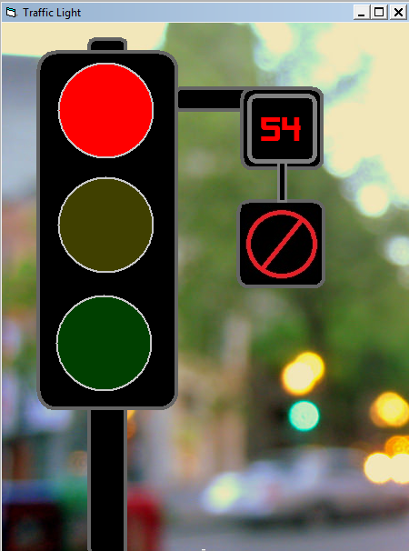 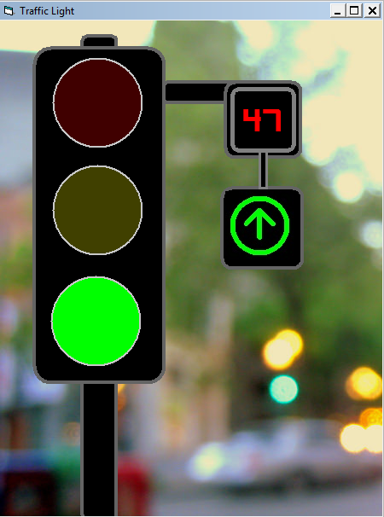

Using Single Timer

Design Time Properties

|  |  |
| --- | --- |
| **frmMain** | |
| Caption | Traffic Light |
| BorderStyle | 1 – Fixed Single |
| Picture | Custom Background |
|  | |
| **shpBody1** to  **shpBody7** | Shapes used to create traffic light |
|  | |
| **shpYellow** | |
| Shape | Circle |
| FillColor | &H00008080& |
| FillStyle | 0 - Solid |
| BorderWidth | 2 |
| BorderColor | &H00008000& |
|  | |
| **lblTime** | |
| Caption | 59 |
| ForeColor | &H000000FF& |
| Font | Alien Encounters |
|  | |
| **imgStop** and  **imgGo** | Image for stop/start signal |
|  | |
| **pBox1** to  **pBox3** | Picture boxes for containing lights, signals and time to minimize flickering while switching colors and text. |

|  |  |
| --- | --- |
| **shpRed** | |
| Shape | Circle |
| FillColor | &H000000FF& |
| FillStyle | 0 - Solid |
| BorderWidth | 2 |
| BorderColor | &H80000000& |
|  | |
| **shpGreen** | |
| Shape | Circle |
| FillColor | &H000000FF& |
| FillStyle | 0 - Solid |
| BorderWidth | 2 |
| BorderColor | &H00008000& |
|  | |
| **tmrMain** | (Timer for signal) |
| Interval | 55000 |
|  | |
| **tmrClock** | (Timer for clock) |
| Interval | 1000 |

Code

Private Sub Form_Load()

shpRed.FillColor = &HFF&

imgStop.Visible = True

End Sub

Private Sub tmrClock_Timer()

If Val(lblTime.Caption) > 0 Then

lblTime.Caption = Format((Val(lblTime.Caption) - 1), "00")

Else

lblTime.Caption = "59"

End If

End Sub

Private Sub tmrMain_Timer()

If shpRed.FillColor = &HFF& Then

shpRed.FillColor = &H40&

shpYellow.FillColor = &HFFFF&

tmrMain.Interval = 5000

ElseIf shpYellow.FillColor = &HFFFF& Then

shpYellow.FillColor = &H8080&

shpGreen.FillColor = &HFF00&

imgStop.Visible = False

imgGo.Visible = True

tmrMain.Interval = 60000

ElseIf shpGreen.FillColor = &HFF00& Then

shpGreen.FillColor = &H8000&

shpRed.FillColor = &HFF&

imgStop.Visible = True

imgGo.Visible = False

tmrMain.Interval = 55000

End If

End Sub

Design Time Properties

|  |  |
| --- | --- |
| **frmMain** | |
| Caption | Traffic Light |
| BorderStyle | 1 – Fixed Single |
| Picture | Custom Background |
|  | |
| **shpBody1** to  **shpBody7** | Shapes used to create traffic light |
|  | |
| **shpYellow** | |
| Shape | Circle |
| FillColor | &H00008080& |
| FillStyle | 0 - Solid |
| BorderWidth | 2 |
| BorderColor | &H00008000& |
|  | |
| **lblTime** | |
| Caption | 59 |
| ForeColor | &H000000FF& |
| Font | Alien Encounters |
|  | |
| **imgStop** and  **imgGo** | Image for stop/start signal |
|  | |
| **pBox1** to  **pBox3** | Picture boxes for containing lights, signals and time to minimize flickering while switching colors and text. |

|  |  |
| --- | --- |
| **shpRed** | |
| Shape | Circle |
| FillColor | &H000000FF& |
| FillStyle | 0 - Solid |
| BorderWidth | 2 |
| BorderColor | &H80000000& |
|  | |
| **shpGreen** | |
| Shape | Circle |
| FillColor | &H000000FF& |
| FillStyle | 0 - Solid |
| BorderWidth | 2 |
| BorderColor | &H00008000& |
|  | |
| **tmr1** |  |
| Interval | 55000 |
|  | |
| **tmr2** |  |
| Interval | 5000 |
|  |  |
| **tmr3** |  |
| Interval | 60000 |
|  |  |
| **tmrClock** |  |
| Interval | 1000 |

Code

Private Sub Form_Load()

tmr1.Enabled = True

End Sub

Private Sub tmr3_Timer()

shpRed.FillColor = &HFF&

shpGreen.FillColor = &H4000&

imgStop.Visible = True

imgGo.Visible = False

tmr3.Enabled = False

tmr1.Enabled = True

End Sub

Private Sub tmr1_Timer()

shpRed.FillColor = &H40&

shpYellow.FillColor = &HFFFF&

tmr2.Enabled = True

tmr1.Enabled = False

End Sub

Private Sub tmr2_Timer()

shpYellow.FillColor = &H4040&

shpGreen.FillColor = &HFF00&

imgStop.Visible = False

imgGo.Visible = True

tmr3.Enabled = True

tmr2.Enabled = False

End Sub

Private Sub tmrClock_Timer()

If Val(lblTime.Caption) > 0 Then

lblTime.Caption = Format((Val(lblTime.Caption) - 1), "00")

Else

lblTime.Caption = "59"

End If

End Sub

Marquee

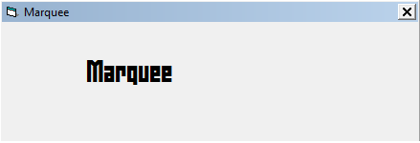

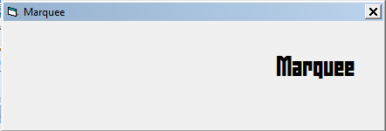

Design Time Properties

|  |  |
| --- | --- |
| **frmMain** | |
| BorderStyle | 1 – Fixed Single |
| Caption | Marquee |
|  | |
| **tmr1** | |
| Interval | 1 |
|  | |
| **tmr2** |  |
| Interval | 1 |
|  | |
| **pBoxText** | (Container for text) |
|  | |
| **lblText** | |
| Caption | Marquee |
| Font | Zephyrean BRK/24 |

Code

**Private Sub tmr1_Timer()**

pBoxText.Left = pBoxText.Left + 30

If pBoxText.Left + pBoxText.Width > frmMain.ScaleWidth Then

tmr2.Enabled = True

tmr1.Enabled = False

End If

**End Sub**

**Private Sub tmr2_Timer()**

pBoxText.Left = pBoxText.Left - 30

If pBoxText.Left < 0 Then

tmr1.Enabled = True

tmr2.Enabled = False

End If

**End Sub**

Alarm Clock

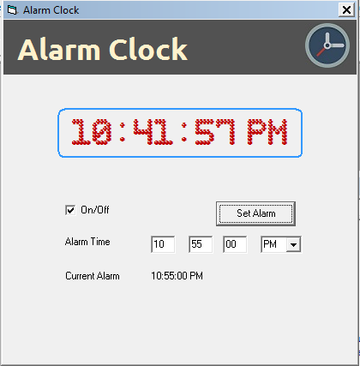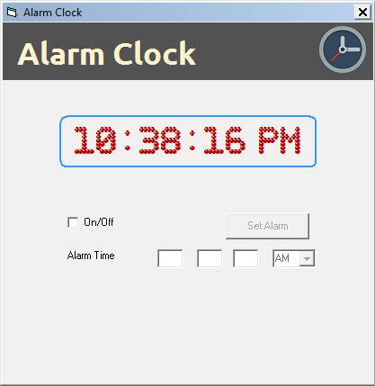

Design Time Properties/Objects

|  |  |
| --- | --- |
| frmMain | |
| Caption | Alarm Clock |
| BorderStyle | 1 – Fixed Single |
|  | |
| lblTitle |  |
| Caption | Alarm Clock |
| Font | Ubuntu/26 |
|  | |
| imgClock | Placeholder for clock icon |
|  | |
| pBoxTime | Picture box container for time |
| Font | Bubble Pixel-7 Dark/20 |
| AutoRedraw | True |
| BorderStyle | 0 – None |
|  | |
| tmrMain | |
| Interval | 1000 |
|  | |
| tmrAlert | |
| Interval | 1000 |

|  |  |
| --- | --- |
| chkOnOff | |
| Caption | On/Off |
|  | |
| lblSetAlarm | |
| Caption | Alarm Time |
|  | |
| cmdSet | |
| Caption | SetA Alarm |
|  | |
| txtHH, txtMM and txtSS | |
| Maxlength | 2 |
|  | |
| cmbAMPM | Combo-box for selecting AM or PM |
|  | |
| lblAlarmTimeD | |
| Caption | Current Alarm |
|  | |
| lblAlarmTime | |
| Caption | Not – Set |

Code

Private Sub chkOnOff_Click()

If chkOnOff.Value = 1 Then

txtHH.Enabled = True

txtMM.Enabled = True

txtSS.Enabled = True

cmbAMPM.Enabled = True

cmdSet.Enabled = True

lblAlarmTimeD.Visible = True

lblAlarmTime.Visible = True

Else

txtHH.Enabled = False

txtMM.Enabled = False

txtSS.Enabled = False

cmbAMPM.Enabled = False

cmdSet.Enabled = False

lblAlarmTime.Visible = False

lblAlarmTimeD.Visible = False

tmrAlert.Enabled = False

frmMain.BackColor = &H8000000F

End If

End Sub

Private Sub cmdSet_Click()

If Val(txtHH.Text) > 0 And Val(txtHH.Text) <= 12 And _

Val(txtMM.Text) >= 0 And Val(txtMM.Text) < 60 And _

Val(txtSS.Text) >= 0 And Val(txtSS.Text) < 60 Then

lblAlarmTime.Caption = txtHH.Text + ":" + txtMM.Text + ":" + txtSS.Text + " " + cmbAMPM.Text

Else

Call MsgBox("Invalid Time!", vbCritical + vbOKOnly, "Error")

End If

End Sub

Private Sub Form_Load()

shpBar1.FillColor = RGB(82, 82, 82)

lblTitle.ForeColor = RGB(255, 242, 204)

cmbAMPM.AddItem ("AM")

cmbAMPM.AddItem ("PM")

cmbAMPM.ListIndex = 0

Call chkOnOff_Click

End Sub

Private Sub tmrAlert_Timer()

If frmMain.BackColor = &H8000000F Then

frmMain.BackColor = vbRed

Else

frmMain.BackColor = &H8000000F

End If

End Sub

Private Sub tmrMain_Timer()

pBoxTime.Cls

pBoxTime.Print (Format(Now, "hh:mm:ss AM/PM"))

If chkOnOff.Value = 1 And (lblAlarmTime.Caption = Format(Now, "hh:mm:ss AM/PM")) Then

tmrAlert.Enabled = True

End If

End Sub

Private Sub txtHH_KeyPress(KeyAscii As Integer)

If (KeyAscii >= vbKey0 And KeyAscii <= vbKey9) Or KeyAscii = vbKeyBack Then

Exit Sub

Else

KeyAscii = 0

End If

End Sub

Private Sub txtMM_KeyPress(KeyAscii As Integer)

If (KeyAscii >= vbKey0 And KeyAscii <= vbKey9) Or KeyAscii = vbKeyBack Then

Exit Sub

Else

KeyAscii = 0

End If

End Sub

Private Sub txtSS_KeyPress(KeyAscii As Integer)

If (KeyAscii >= vbKey0 And KeyAscii <= vbKey9) Or KeyAscii = vbKeyBack Then

Exit Sub

Else

KeyAscii = 0

End If

End Sub